The School District City of Erie, PA

**July 2025**

Bidder Must Deposit With

Bid – **CERTIFIED CHECK** Or

BID BOND 5% of Total Bid

**BID ON –** Two (2) American Turnmaster Clausing Colchester Lathe (Model AT-1340-G-TW) and Associated Training

## The Board of Directors

of the School District

of the City of Erie, PA

Gentlemen:

We, the undersigned, propose to furnish and install the following **BID** Two (2) American Turnmaster Clausing Colchester Lathe (Model AT-1340-G-TW) and Associated Training

**:**

DOLLARS ($_____________)

Bids shall be sealed and endorsed on the envelope, or on the subject line on electronic submissions, **“**Two (2) American Turnmaster Clausing Colchester Lathe (Model AT-1340-G-TW) and Associated Training**”** and delivered to School District of the City of Erie, Administration Building,1910 Sassafras Street, Erie, PA 16502, Board Secretary Office, ATTN: BIDS, by August 5th by 11:00 am. Bids shall be delivered in either person, via USPS, a contract carrier such as UPS, FedEx, etc., or via electronic submission to bids@eriesd.org.  Late bids will be rejected.  Bids will be opened utilizing an online format on August 5th at 11:30. Award of bid may be made at the regular meeting of the Board onAugust 13th, 2025 at 6:00 pm.

The School District will conduct the bid opening utilizing an online format at the date and time identified above. The School District will provide interested proposers with a link to participate in the bid opening. If an interested proposer requires reasonable accommodations to participate in an online format bid opening due to a disability, if the interested proposer wishes to participate in the meeting but does not have internet access, or if a member of the public wishes to view the opening electronically, contact Neal Brokman, Assistant Superintendent, at [nbrokman@eriesd.org](mailto:nbrokman@eriesd.org).

The Board of School Directors will consider accepting the bid of the lowest responsible bidder meeting specifications, kind, quality and material being equal, but shall have the right to reject any and all bids and to waive defects in form. The Board is not obligated to accept the lowest or any other bid.

Respectfully submitted:

**The School District City of Erie, PA**

***Dr. Natalyn Gibbs District Administration Building***

***Superintendent of Schools 1910 Sassafras Street Erie PA 16502***

# GENERAL CONDITIONS

Bids shall be submitted on the Bidding Blank attached hereto, and should be submitted through the means identified on the Bidding Blank.

No bids will be entertained unless accompanied by a deposit, as a **CERTIFIED CHECK or BID BOND** in the amount of five per cent (5%) of the total bid, made payable to The School District City of Erie and enclosed in the envelope containing the bid.

No bid received can be withdrawn prior to the close of the regular meeting of the Board of School Directors next succeeding the opening of the bids. Bidder agrees that the School District of the City of Erie shall have up to sixty (60) days to accept or reject the bid and bidder agrees that the bid quote shall remain open for that period. The Board of School Directors may reject any bid, or portion of any bid, for any reason or no reason.

The special attention of the bidders is directed to the fact that no claims for relief on account of mistakes or omissions in the bidding will be considered and the contractors will be held strictly to their bids, or, alternatively, and at the sole discretion of the Board of School Directors, their deposit may be forfeited. In addition to other remedies available to the School District, the deposit shall be forfeited if the successful bidder fails to execute an agreement or perform as required.

**Standard of Quality**: The specific mention of a manufacturer’s name shall be understood to indicate a standard of quality or design, and not as limiting competition thereon or excluding other goods equal in every respect to the materials or goods specified in the opinion of the Controller or his designee. If you do not bid on our specifications as listed, please fill in manufacturer’s name and model number of items you intend to furnish as an equal alternate. The Career and Technical Educational Director, or his designee, shall determine, in his sole discretion, whether the alternate item is an approved equal.

Bidders are to submit prices on both the rate and the total. Bidders please indicate length of time prices will remain firm. If a “Rate” is given on an item, a “Total” must be given on the item. Awards may be made item by item and bidders hereby agree to furnish the items awarded to them. All supplies furnished upon the contract not up to specifications will be rejected.

All charges for transportation, freight, express and parcel post are to be paid by the successful bidder. It is understood that the bidder agrees to deliver any items on which bids are accepted.

Completion of contract shall not exceed sixty days after award is made. The successful bidder will be required to execute a contract with the School District if identified as the apparent low bidder. A fully executed contract must be received by the School District prior to final award by the Board of School Directors. The form of the contract is enclosed with this bid packet.

All items to be delivered to the Erie High School. If you have any questions, please contact Jason Burgert, Career and Technical Education Director at 814-874-6225 or [jburgert@eriesd.org](mailto:jburgert@eriesd.org).

**SPECIFICATIONS**

The following specifications are approved by the Board of Directors for purchase or approved equal as approved by the Career and Technical Education Director.

# AMERICAN TURNMASTER

13” TOOL ROOM LATHE

DESIGNED, ASSEMBLED, & TESTED IN LOS ANGELES, CA

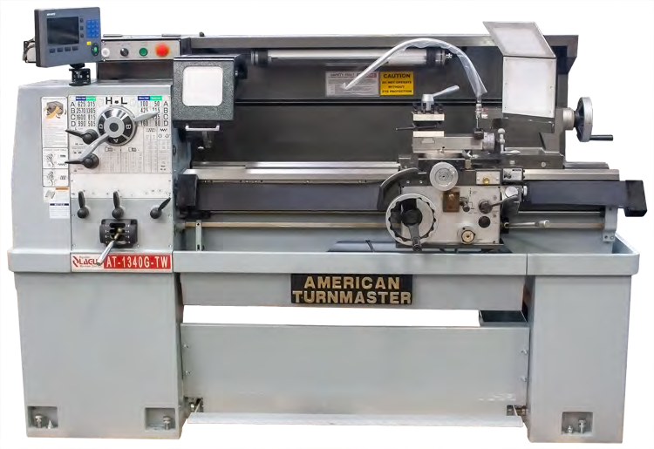

MODEL 1340-G-T-W SHOWN WITH SOME OPTIONAL ACCESSORIES

REVISED P: 3/20/2024

P.O. : 1/29/2024 F: 11/29/2022 E:

WE ARE PLEASED TO QUOTE FOR YOUR CONSIDERATION, OUR AMERICAN TURNMASTER TOOL ROOM LATHE MODEL:

## AT-1340-G-TW

* 3 V WAYS, HARDENED AND GROUND
* 16 SPEED SPINDLE FROM 50 UP TO 2,750 RPM
* BALANCED MAIN SPINDLE
* TAILSTOCK SPINDLE WITH AMERICAN TANG
* CARRIAGE WITH TURCITE TO ELIMINATE STICK SLIP, DAMP CUTTING VIBRATIONS
* SAFETY CARRIAGE STOP
* HEAVY CAST IRON MACHINE

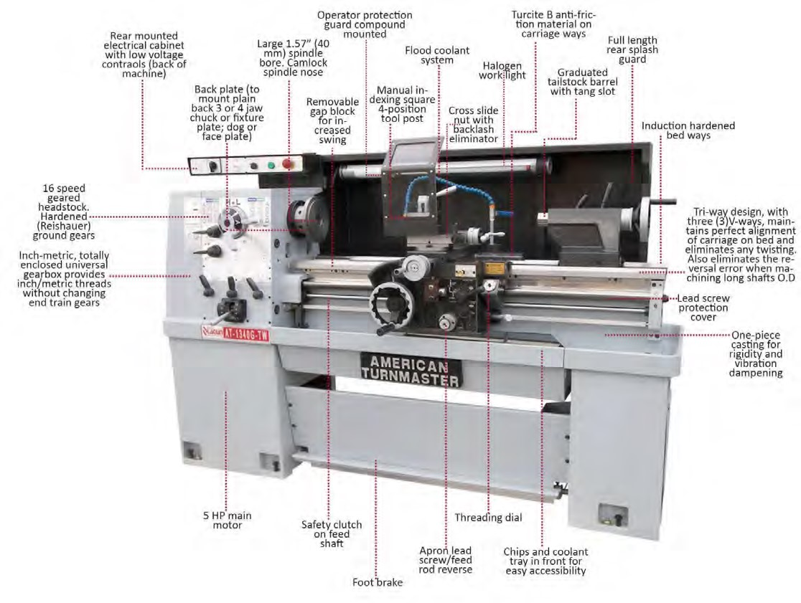

## FEATURES

STANDARD

### GEARED HEADSTOCK

* HEAVY DUTY GEARED HEAD WITH FORGED ALLOY STEEL SPINDLE

(DYNAMICALLY BALANCED) MOUNTED ON TIMKEN® TAPER ROLLER BEARINGS - USING TWO TAPER ADJUSTABLE ROLLER BEARINGS.

* ALL GEARS AND SHAFTS ARE HARDENED AND REISHAUER GROUND.
* HOUSING IS VIBRATION ABSORBENT AND DEFLECTION FREE.
* SPLASH LUBRICATION.
* HEADSTOCK AND GEARBOX HAVE OIL BATH SYSTEM FOR LUBRICATION.
* SPEEDS: 16 SPEEDS WITH A TWO-SPEED MOTOR.
* SPINDLE: HEAVY DUTY CAMLOCK SPINDLES, D1-4.

AT-1340 GEARBOX

### UNIVERSAL GEAR BOX

* INCH/METRIC TOTALLY ENCLOSED UNIVERSAL GEARBOX PROVIDES OF INCH & METRIC THREADS WITHOUT CHANGING END TRAIN GEARS- TO SAVE TIME.
* GEARS ARE HARDENED-SHAFTS TURN ON ANTI-FRICTION BEARINGS-MECHANISM RUNS IN OIL BATH.
* SEPARATE ROD FOR POWER FEEDS - LEADSCREW IS USED FOR THREAD CUTTING ONLY.
* CLUTCH IN FEED ROD AND SHEAR PIN IN LEAD SCREW PROTECT AGAINST OVERLOAD.
* THREAD AND FEED CHART FOR INCH & METRIC FEED.
* CENTRALIZED PUSH BUTTON CONTROLS WITH E-STOP AND SPINDLE JOG. (1)

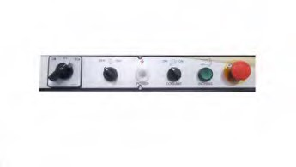

1

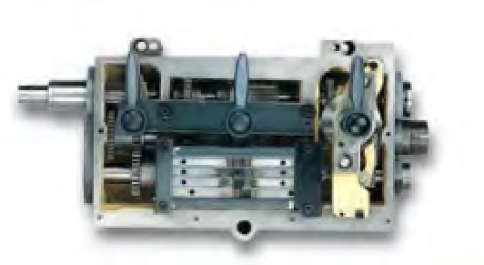

#### CARRIAGE AND CROSS SLIDE

* WIDE, FULL-LENGTH CROSS SLIDE EXTERNALLY DOVE-TAILED FOR QUICK AND EASY MOUNTING OF ACCESSORIES.
* DUAL MICROMETER DIALS (INCH & METRIC) WITH DIRECT READINGS. FOR CROSS AND COMPOUND FEEDS.

IMMEDIATE CHANGE-OVER FROM INCH TO METRIC READINGS THROUGH DIAL WINDOW.

* CARRIAGE WITH TURCITE® MATERIAL ON THE SLIDING SURFACES, TO ELIMINATE “STICK SLIP” AND DAMPEN CUTTING VIBRATIONS.
* ANTI-FLOAT DESIGN, BACKLASH ELIMINATOR FITTED IN CROSS SLIDE NUT.
* SAFETY CLUTCH AT FEED SHAFT.
* ONE SHOT LUBRICATION IN CARRIAGE & TOP SLIDE.

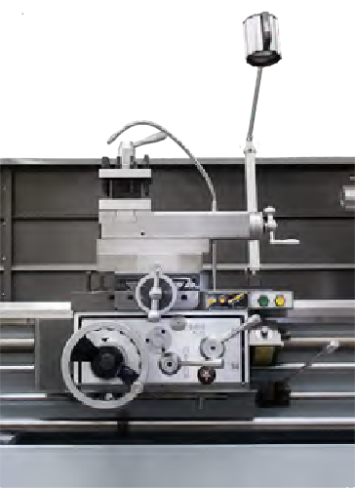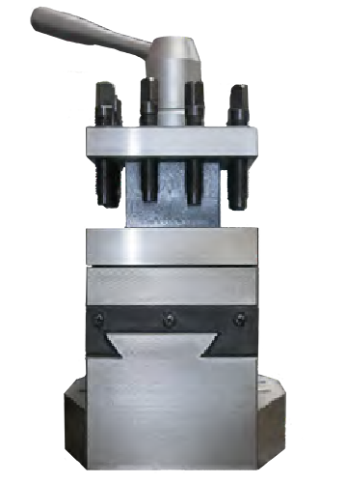

LATHE CARRIAGE 4 WAY TOOL POST

#### APRON

* FORWARD-OFF-REVERSE SPINDLE CONTROL PROVIDED BY GATED LEVER AT APRON.
* PRESSURE ONE SHOT LUBE FOR CARRIAGE AND CROSS SLIDE.
* CROSS LEAD SCREW WITH BACKLASH ELIMINATOR.

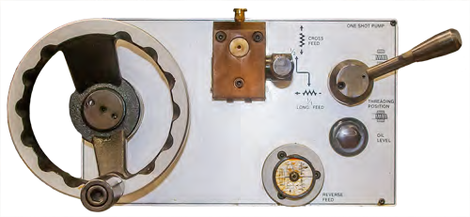

AT-1340 APRON

#### COMPOUND

• T-SLOTTED FOR EASY TOOL HOLDER MOUNT. FEATURES

TAPERED GIBS AND INCH/METRIC DIALS. SWIVEL WITH

GRADUATED DEGREE MARKS FOR QUICK REFERENCE. (1)

(1)

#### BED

* TRI-V WAY (TW) BED DESIGN. (2)
* ULTRA-RIGID, MEEHANITE CASTING MOUNTED ON CAST IRON BASE.
* INDUCTION HARDENED AND PRECISION GROUND BED WAYS. MINIMUM HR-70.
* PROVIDES PERFECT ALIGNMENT AND PREVENTS VIBRATIONS.
* GAP BED DESIGN

(2)

FLOOD COOLANT SYSTEM

* CHIP & COOLANT TRAY (FRONTAL REMOVAL)

#### ELECTRICS

* ALLEN BRADLEY ELECTRICS (OPTIONAL)
* 3/60/220 VOLTS (STD)
* 440 VOLTS (OPTIONAL)

AT-1340 ELECTRICAL CABINET

#### SAFETY FEATURES

* LOW VOLTAGE CONTROLS
* NYLON SAFETY GEARS IN END TRAIN
* SHEAR PIN IN LEADSCREW
* FEED ROD WITH SLIP CLUTCH
* FULL LENGTH FOOT BRAKE (1)

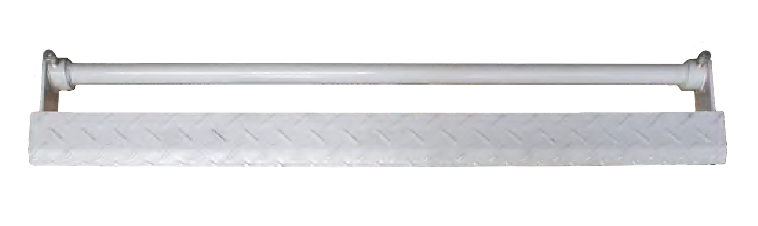

1

SAFETY GUARDING (STANDARD)

•

REPUBLIC-LAGUN HAS AVAILABLE CERTAIN SAFETY

SHIELDS AND GUARDS APPLICABLE TO OUR MACHINES

THAT WE BELIEVE WILL MEET THE INTENT OF OSHA AND

MAY BE APPROPRIATE FOR YOUR APPLICATION.

◦

CHUCK GUARD WITH SAFETY LIMIT SWITCH. (

1

)

◦

COMPOUND PROTECTION GUARD. (

2

)

◦

SAFETY GUARD TO COVER “LEADSCREW” AND “FEED ROD

BAR”. (

3

)

◦

REAR SPLASH GUARD (

4

)

; WITH BUILT IN WORK LIGHT,

ELIMINATING GLARE.(

4.1

)

◦

INCORPORATED TO THE REAR GUARD ROOF IS THE

“CABLE RACK” THAT WILL KEEP ALL CABLES RUNNING

ABOVE THE CHIP AND COOLANT AREA PREVENTING ANY

CONTAMINATION. (

4.2

)

◦

ALSO THE REAR GUARD HAS IN THE MIDDLE AN EASY TO

REMOVE INSPECTION WINDOW .(

4.3

)

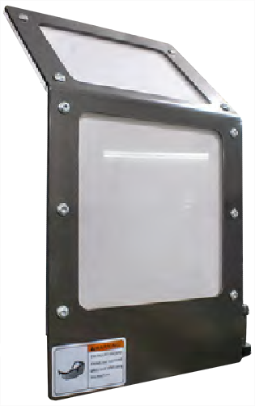

(2)

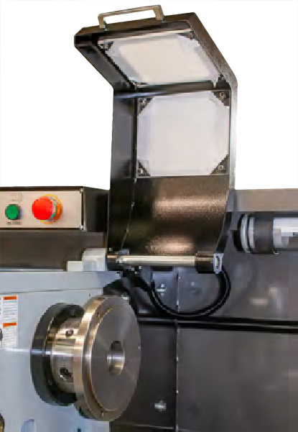

(1)

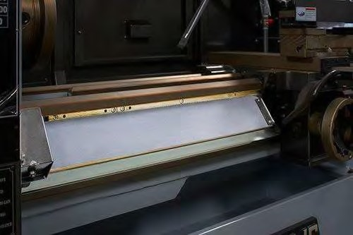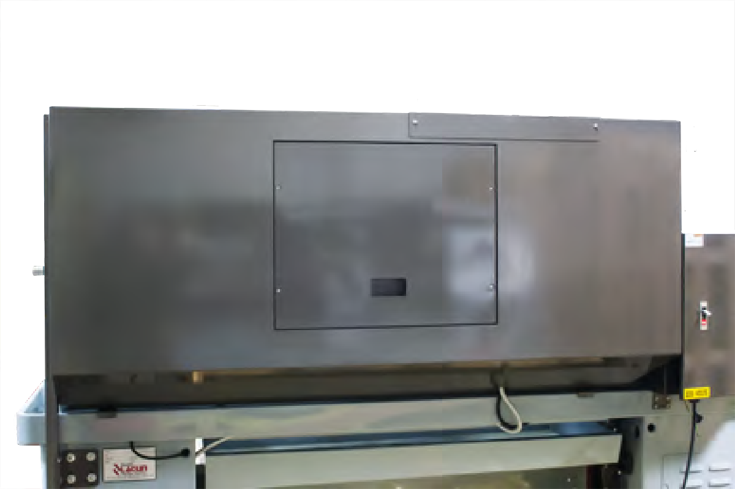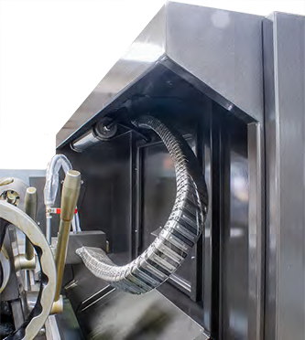

(3) (4.3) (4 / 4.1 / 4.2)

### OPTIONAL

#### DIGITAL READ-OUT SYSTEM

* ENHANCE PRODUCTIVITY WITH AN OPTIONAL DIGITAL READOUT SYSTEM (ACURITE OR NEWALL).
* OPERATOR FRIENDLY DIGITAL READOUT SYSTEMS THAT REDUCE SETUP TIME AND INCREASE PRODUCTIVITY.
* 2 OR 3 AXIS DISPLAYS
* ACU-RITE CAN FEATURE CONSTANT SURFACE SPEED (CSS) WHICH EXTENDS TOOL LIFE.

#### THREAD ASSIST

• CUTTING METRIC THREADS ON AMERICAN TURNMASTER LATHES EQUIPPED WITH AN ENCODER AND THE ACU-RITE 300S DRO WITH THE THREAD CYCLE IS AS EASY AS CUTTING INCH THREADS.

##### ELECTRONIC VARIABLE SPEED -EVS(OPTIONAL)

• INFINITELY VARIABLE SPINDLE SPEEDS 20 TO 3000 RPM IN TWO MANUAL SHIFT RANGES.

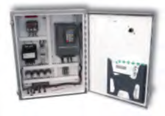

##### RPM READOUT (ON EVS LATHES ONLY)

• HEADSTOCK MOUNTED RPM READOUT WITH SPINDLE SPEED CONTROL DIAL. STANDARD ON ALL EVS LATHES. 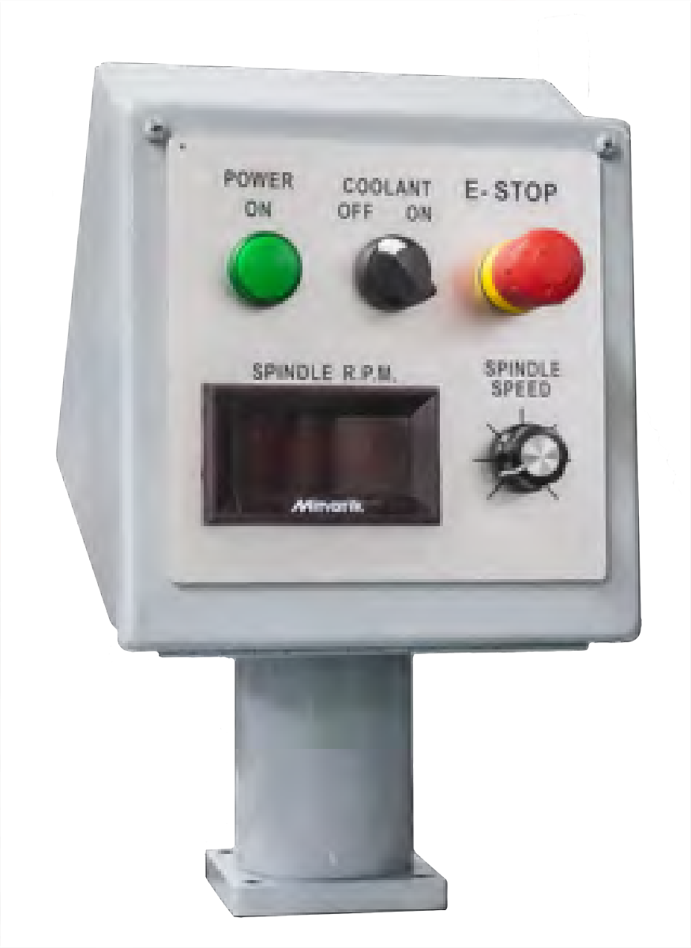

##### “A” SERIES -MADE IN USA VERSION (OPTIONAL)

• COMPLETE 3/60/220 VOLT ELECTRICS TO NFPA & NEMA STANDARDS & U.L.® APPROVED, WITH E-STOP, RPM INDICATOR & LOW VOLTAGE TO HEADSTOCK CENTRALIZED CONTROLS.

*\*PLEASE ASK LAGUN SALES REP FOR MORE DETAILS.*



## MACHINE SPECIFICATIONS

|  |  |
| --- | --- |
| MODEL: | AT-1340-G-TW |
| CAPACITY |  |
| SWING OVER BED | 13.39” (340 MM) |
| SWING OVER CROSS SLIDE | 8.27” (210 MM) |
| DISTANCE BETWEEN CENTERS | 39.37” (1,000 MM) |
| HEADSTOCK |  |
| SPINDLE NOSE, CAM-LOCK | D1-4 |
| SPINDLE BORE | 1.57” (40 MM) |
| SPINDLE SPEED (HI-LOW) | 16 STEPS |
| SPINDLE SPEED RANGE: STANDARD | 50 TO 2,570 RPM |
| LOW RANGE | 50-80-135-215-315-505-815-1,305 |
| HIGH RANGE | 100-160-265-425-625-990-1,600-2,570 |
| CARRIAGE |  |
| LENGTH ON BED | 15.75” (400 MM) |
| WIDTH OF BRIDGE | 15.12” (384 MM) |
| CROSS SLIDE TRAVEL | 7.09” (180 MM) |
| TOP SLIDE TRAVEL | 3.94” (100 MM) |
| BED |  |
| NUMBER OF V WAYS | 3 “V’ WAYS |
| BED WIDTH | 9.06” (230 MM) |
| SWING IN GAP | 20.16” (512 MM) |
| GAP LENGTH FROM FACEPLATE | 5.91” (150 MM) |
| TAILSTOCK |  |
| QUILL DIAMETER | 1.97” (50 MM) |
| QUILL CENTER | M.T.3 |
| QUILL TRAVEL | 4.41” (112 MM) |
| FEEDS AND THREADS |  |
| RANGE OF WHIT WORTH THREADS & NO. | 2-72 T.P.I. (45) |
| RANGE OF METRIC THREADS & NO. | 0.2-14 (39) |
| RANGE OF D.P. & NO. | 8-44 (21) |
| RANGE OF M.P. & NO. | 0.3-3.5 (18) |
| MODEL: | AT-1340-G-TW |
| LONGITUDINAL FEED | 0.002-0.067” (0.05-1.7 MM) |
| CROSS FEEDS | 0.0009-0.034” (0.025-0.85 MM) |
| MOTOR |  |
| MAIN MOTOR, 2-SPEED, 3/60/220 V | 5 HP (3.73 KW) |
| COOLANT PUMP | 0.12 HP (0.09 KW) |
| MEASUREMENTS |  |
| LENGTH PACKED | 89.37” (2,270 MM) |
| WIDTH PACKED | 38” (965 MM) |
| HEIGHT PACKED | 68.70” (1,745 MM) |
| WEIGHT |  |
| GROSS WEIGHT | 2,855 LBS. (1,295 KG) |

*\*ALL SPECIFICATIONS SUBJECT TO CHANGE WITHOUT PRIOR NOTICE.*

### • CHIP AND COOLANT TRAY • FOOT BRAKE • FULL LENGTH REAR SPLASH GUARD • CHUCK GUARD AND LIMIT SWITCH • COMPOUND PROTECTION GUARD (WITHOUT LIMIT SWITCH) • MANUAL INDEXING SQUARE 4-POSITION TOOL POST • BACK PLATE (TO MOUNT PLAIN BACK 3 OR 4 JAW CHUCK OR FIXTURE PLATE; DOG OR FACE PLATE) • TWO (2) NO. 3 MT CENTERS AND MAIN SPINDLE REDUCTION SLEEVE • LEAD SCREW PROTECTION COVER • SAFETY CLUTCH ON FEED SHAFT • EMERGENCY STOP BUTTON • WORK LIGHT • OPERATOR PROTECTION GUARD COMPOUND MOUNTED • TOOLBOX AND MANUALS • LEVELING PADS AND BOLTS • THREADING DIAL • INCH/METRIC DUAL DIALS ON CROSS SLIDE; COMPOUND & TAILSTOCK • ELECTRICS 220V (STD) /440V (OPTIONAL), 3 PHASE, 60 HZ (OTHER OPTIONS AVAILABLE) • FLOOD COOLANT SYSTEM

STANDARD ACCESSORIES

PLEASE NOTE: Outside the above referenced specifications the District is looking to get the adjustable tool holder and not the 4way holder. Additionally, the machine tool must include a 4 jaw chuck and not independent.

NAME OF VENDOR

ADDRESS

CONTACT PERSON

TELEPHONE NUMBER

First, the undersigned having carefully examined the **Bid** Two (2) American Turnmaster Clausing Colchester Lathe (Model AT-1340-G-TW) and Associated Training in accordance with the specifications of the proposal, submits this proposal and agrees to furnish and perform the specified Two (2) American Turnmaster Clausing Colchester Lathe (Model AT-1340-G-TW) and Associated Training for the School District of the City of Erie for the amounts indicated on page 1 of the Bid.

Second, the undersigned agrees to enter into a written contract to furnish such materials and services as required in the proposal specifications.

Third, the following quotation prices are listed as firm for a period of __________ after the due date of this request for bid.

**NOTE: The School District of the City of Erie will not be liable and will not pay for any applicable costs not included and detailed in the Bid.**

Signature

Date

Title or Office

**INSTRUCTIONS FOR NON-COLLUSION AFFIDAVIT**

1. This Non-Collusion Affidavit is material to any contract awarded pursuant to this RFP. According to the Pennsylvania Antibid-Rigging Act. 73 P.S. 1611 et seq. governmental agencies may require Non-Collusion Affidavits to be submitted together with bids or RFP’s.
2. This Non-Collusion Affidavit must be executed by the member, officer or employee of the Vendor who makes the final decision on prices and amounts quoted in the RFP.
3. Bid/RFP rigging and other efforts to restrain competition, and the making of false sworn statements in connection with the submission of bids or RFP’s are unlawful and may be subject to criminal prosecution. The person who signs the affidavit should examine it carefully before signing and assure himself/herself that each statement is true and accurate, making diligent inquiry, as necessary, of all other persons employed by or associated with the Vendor with responsibilities for the preparation, approval, or submissions of the RFP.
4. In case of a RFP submitted by a joint venture, each party to the venture must be identified in the RFP/Bid documents, and an affidavit must be submitted separately on behalf of each party.
5. The term “complementary RFP” as used in the Affidavit has the meaning commonly associated with that term in the bidding/RFP process, and includes the knowing submission of RFP’s higher than the RFP of another Vendor, any intentionally high or noncompetitive RFP, and any other form of RFP submitted for the purpose of giving a false appearance of competition.
6. Failure to file an Affidavit in compliance with these instructions will result in disqualification of the RFP.

**NON-COLLUSION AFFIDAVIT**

**BID ON –** Two (2) American Turnmaster Clausing Colchester Lathe (Model AT-1340-G-TW) and Associated Training

State of

County of

I state that I am of

(Title) (Name of Vendor)

and that I am authorized to make this affidavit on behalf of my company, and its owners, directors, and officers, I am the person responsible in my company for the price(s) and the amount of this Request for Proposal (RFP).

I state that:

1. The price(s) and amount of this RFP have been arrived at independently and without consultation, communication, or agreement with any other Vendor.
2. Neither the price(s) nor the amount of this RFP, and neither the approximate price(s) nor the approximate amount of this RFP, have been disclosed to any other Vendor, and they will not be disclosed before the RFP submission to The School District of the City of Erie.
3. No attempt has been made or will be made to induce any Vendor or person to refrain from submitting an RFP to The School District of the City of Erie, or to submit an RFP higher than this RFP, or to submit any intentionally high or noncompetitive RFP or other form of complementary RFP.
4. The RFP of my company is made in good faith and not pursuant to any agreement or discussion with or inducement from, any Vendor or person to submit a complementary or other noncompetitive RFP.
5. , its affiliates, subsidiaries, officers, directors and employees

(Name of my Company)

are not currently under investigation by any governmental agency and have not in the last four years been convicted or found liable for any act prohibited by State or Federal law in any jurisdiction, involving conspiracy or collusion with respect to submitting an RFP to any public entity, except as follows:

I state that understand and acknowledges that the above

(Name of my Company)

representations are material and important, and will be relied on by The School District of the City of Erie when recommending for award the agreement for which this RFP is submitted, I understand and my company understands that any misstatement in this affidavit is and shall be treated as fraudulent concealment from the School District of the City of Erie of the true facts relating to the submission of RFP’s for this agreement.

Signature of Authorized Person

(Print Name of Authorized Person and Company Position)

Sworn to and subscribed before

Me this day of

, 20

(Notary Public) (My Commission Expires)